Sligo Youthreach
Centre of Education

Quality Framework
Centre Evaluation & Improvement Plan 2021-2022

24th & 25th November 2021

Youthreach is co-funded by the Government of Ireland, the European Social Fund and the Youth Employment Initiative as part of the ESF Programme for Employability, Inclusion and Learning 2014-2020

Introduction

The Quality Framework, Centre Evaluation and Planning Report (CEIP) for the Sligo Youthreach, Centre of Education, is an important contribution to the future development of the programme.
This report has been developed through consultation with learners, centre staff, the centre Coordinator, MSLETB Management, parents and guardians, external supports and agencies.
The process involved two facilitated days during which the stakeholders reflected and reviewed centre practice, prioritised areas for further development and documented a plan of constructive actions for the following year.
The staff team have agreed to take responsibility for the implementation of the Centre Action Plan. The implementation of the centre plan will be monitored, evaluated and included on the agenda of each staff meeting.

Acknowledgements.

I would like to thank Mayo, Sligo, Leitrim, Education and Training Board, Cathy Powell, Adult Education Officer, the centre staff team, learners, parents, guardians, external agencies, and support services, who took part in the Sligo Youthreach Centre Evaluation Improvement Plan (C.E.I.P.) process, for their ongoing support, contributions, feedback and contribution to the Sligo Youthreach centre
I would also like to thank the members of staff who agreed to complete suggestions and actions, within a given time frame. These actions will contribute to ongoing improvements and good practice of the centre.
I would also like to express my gratitude to all those who were involved in the development of the report. I appreciate the hard work and professionalism that was involved as well as the clear commitment to the ongoing improvement of the programmes delivered and services provided by the centre.

Signed______________________
Ultan Mulvihill
Centre Coordinator

Background to Quality Framework

A Quality Framework Initiative (QFI) for Youthreach and Senior Traveller Training Centres was established in November 2000
Primary purpose:
- To assist staff to examine centre practice, identify strengths and challenges and implement actions to improve the service they provide
- Accountability:
  - Annual Reports were to be documented and sent to: -
    - LSMETB’s
    - National Youthreach Coordinator
    - Regional and local management
    - Other relevant organisations
  - Evidence for DES inspectors when they carried out inspections in centres
  - Information for various stakeholders
The overall aim of Quality Framework is to improve the quality of work in centres. This was originally achieved through exploring specific Quality Standards within the framework, by either an Internal Centre Evaluation (ICE) or a Centre Development Planning (CDP) Process
The Quality Framework process aims to achieve the following outcomes:
- Enhancing shared understanding by staff and stakeholder groups, of the overall service that is being provided by centres.
- Teambuilding.
- Capacity Building –where staff become more competent and confident in the delivery of their service.
- Increasing staff engagement, sense of ownership and self-determination.
- Increased intentionality –that centres end up with plan, a sense of direction and a commitment to making progress.
Centre Evaluation and Improvement Plan (CEIP)
At the 2014 National Association of Youthreach Coordinator (NAYC) annual conference, a working group was set up and given a mandate, to review and update the original Quality Framework and Quality Standards, guidelines and support material.
The working group consisted of Gerry Griffin, the National Youthreach Co coordinator and four Q.F. Facilitators, Lorraine O Leary, Josephine Dempsey, Theresa McLoughlin and Maura White. Dr. Mary Gordon, National Education Psychological Services (NEPS), with responsibility for Guidance, Counselling and Psychological services within Youthreach, was invited to attend meetings in order to include her areas of expertise on new Quality Standard areas within the framework. Sheila Sullivan, Quality Framework facilitator was contracted, on behalf of the working group to compile the revised Quality Standards, guidelines and relevant support materials.
During 2014-2016 the working group reviewed and updated the Quality Framework process to reflect current needs and legislation. The original ICE and CDP processes that were central to Quality Framework were incorporated into a new process called CEIP - Centre Evaluation and Improvement Plan.
The original 27 Quality Standards were reviewed, some combined, others updated, and six new standard areas were added to reflect the present requirements of centres, ETBs, the Department of Education and Skills inspectorate and guidelines. The new areas are:-
- 14 Critical Incident Planning
- 15 Support Services and Practices
- 16 Implementation of the WEB Wheel model in centres.
- 17 Evaluation of the SEN Initiative in SENI centres.
- 21 Implementation and Evaluation of Soft Skills Framework
- 23 Teaching and Learning.
There continues to be scope, within the new CEIP process, for centres to evaluate other areas of importance, such as programmes, activities, methodologies, etc that are relevant to the centre.
The CEIP Process - Centre Evaluation and Improvement Plan was rolled out to all Youthreach centres during 2016.
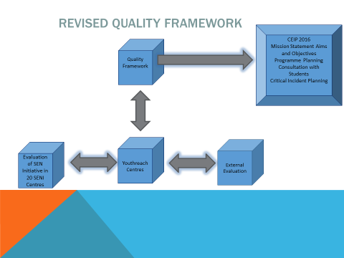
History of Youthreach Sligo

History of Youthreach Sligo
Youthreach Sligo was established in Sligo Town in May 1989 by Sligo VEC under the guidance of Mr. Jim Sproule C.E.O.. The centre opened in a converted factory building in the St. Anne’s area of Sligo with seventeen young people and five staff attending on the first day.
The centre experimented with many different ideas and subjects on how best to engage with early school leavers, gaining experience and learning from what worked well in those early years. Sport always featured strongly on the curriculum, with the centre entering a team in the Sligo / Leitrim Junior Soccer League in 1990. The team was made up of players from learners and staff in the centre as well as parents of the learners. This sporting theme carried on over the years with Youthreach Sligo winning the All Ireland Youthreach 5 A side indoor soccer competition in 1998 and again in 2000. On one memorable occasion back in 1994 the F.A.I. cup along with the winning Sligo Rovers team visited the centre. A former learner who won the all- Ireland competition with Youthreach back in 2000 Keith Carty went on to play for Sligo Rovers senior team as well as a number of other teams in the league of Ireland.
Since the centre opened back in 1989 almost 1,000 young people have passed through our doors. We like to think all of them have benefited from their time here. We have had many success storie’s but this document is too short to start listing personal accounts on how well so many of our young people have done.
Over the years the centre has taken part in many Cross – Border events to help broaden the horizons of both its participants and staff.
Some of these projects include;
Sligo / Derry Group in Denmark for three months 1991
Sligo / Derry Group in Denmark for three months 1992
Sligo / Derry Group in Denmark for three months 1994
Sligo / Enniskillen Group in Toronto Canada for three months 1997
Sligo / North Down in London for one week 2001
Sligo / North Down in London for one week 2002
Sligo / Belfast / Newry / Clones 4 film Project 2004
North / South Education Forum ( Alternative Education Programme ) 2005

Art and performing arts have also featured strongly on the curriculum of our centre with participation in the St. Patricks day parade a regular feature from 1995 – 1999 and again from 2008 – 2014. Each year we won our section of the competition. We have also written and performed in four films since we first dipped our toe into film making back in 2004 as part of a cross border project.

“The Game” 2006 -2007 Premiered in Gaiety Cinema in 2007
“Watching You Cry” 2009 – 2010 Premiered in Gaiety Cinema in 2010
“Last Chance” 2013 – 2014 Premiered in Gaiety Cinema in 2014
“Three careful Owners” 2015 – 2016 Premiered in Omniplex Sligo in 2016
“ Stephanie’s Story” 2021 Hope to Premier this film in early 2022.

Many of the street puppets which we built for the St. Patricks day parade travelled North to take part in parades and street festivals there.
We ventured into Junk couture in 2013 reaching the regional Finals in Castlebar, and have performed in the Hawks Well Theatre as part of The ETB’s shows, and many African Drumming street performances. We regularly bring groups to theatres such as the Board Gais Theatre Dublin, Linen Mill Castlebar and the Hawks Well in Sligo.
Certification for the first number of years was mainly supplied by City & Guilds, but by 1997 Youthreach Sligo had become one of the fore runners in offering N.C.V.A. Certification, which became F.E.T.A.C. and later Q.Q.I.. Youthreach Sligo then introduced the Junior Cert programme in 2002 and the Leaving Cert Applied in 2008.
In Youthreach Sligo we pride ourselves on not just offering certification but a programme first and foremost, which can be flexible and adapted to best meet the needs of the learners we encounter.
Youthreach Sligo became a pilot centre for the Youthreach Quality Framework Initiative back in 2003 and under the guidance of Shivaun O Brien carried out its first Internal centre Evaluation ( ICE ) that year. We carried out our first Centre Development Plan ( CDP ) in 2007 which ran to 2012, and started Centre Evaluation and Improvement Plans ( CEIP ) from 2016.

In 2007 the centre became a pilot centre for the Special Education Needs Initiative ( SENI ) under the guidance of Mary Gordon. This allowed us to engage in Mentoring support for learners, as well as broaden the number of overall supports which we can now offer to all learners, such as extra literacy support, more personal development programmes as well as Leisure and Recreation. Through the literacy initiative we began writing poetry (both staff and learners ) and wrote our first book of poetry in 2012. This later developed into a National competition from 2015 when we celebrated the 150 birthday of Yeats, the 1916 rising in 2016, Kindness in 2017 and Dreams in 2018. We collected the National Flag at a ceremony in Croke Park in 2016 celebrating 100 years of our great country. We purchased a full sized snooker table to add to our sport facilities in 2017. A great facility to have in any Youthreach centre.
The SENI programme also allowed us to take trips to Spain which included;
Barcelona in 2011
Madrid in 2012
Salou / Barcelona in 2013
We also created a girls group in 2009 which later incorporated the girl’s active programme from 2011 onwards.
We have introduced the Gaisce Award in the centre with our first learner receiving her bronze medal at an awards ceremony in 2016.
The staff team in the centre has been solid over the years with only a small number of changes in personnel. In 2007 Phill Corcoran ( Counsellor ), Damian Beirne ( Woodwork ) and Tracy Mc Garry ( Home Economics ) joined the team with Cuan Prendergast moving down the country closer to home, Mark Lewis emigrating to Australia and Mickey Mc Loughlin retiring. Judith keyes ( English ) joined our team in 2014 and Sinead Mc Loughlin ( History ) joining in 2016. Shane O Down replaced Thomas Doyle teaching metalwork / Engineering in 2017. Shane has since moved on with Nigel Milham about to join the centre team as our new metalwork teacher hopefully before the end of this year ( 2021 ). Anne Heffron ( Guidance counsellor ) retired from the centre in 2019.

Some other highlights include the visit to the centre of President Mary McAleese and her husband Martin in June 2001, Gerry Adams President of Sinn Fein in 2002, Sile De Valera T.D. minister of State Department of Education and Science in December 2005 when she officially opened our new centre and John Perry T.D. on a number of occasions.
A board of management for Youthreach Sligo was set up in 2007 and operated until 2015 when it was replaced by an advisory committee which oversees the work of five Youthreach centres in the Mayo Sligo Leitrim ETB area.
We brought a group of staff and learners to the National Sports Campus for Youthreach Fest, in October ( 2018 ) which celebrated 30 years of the Youthreach programme. A real highlight.
The centre is now in its 33rd year of operation with about 200 years of experience within the staff team.
2019 - 2020 will be the year of Covid 19 which affected the whole world as well as Youthreach Sligo. We were in lockdown for part of it. Carried out our first online classes and continue to work in small pods with face masks as well as many other covid restrictions. Not the best way to operate a Youthreach centre, but as always we do our best in the circumstances which we find ourselves in.

Mission Statement

Mission Statement

To unlock potential in a safe learning environment and to encourage development of personal well - being, abilities and interests.

Aims:

- To provide a positive and creative experience within a safe healthy and supportive environment.

- By offering support to learners through 1:1, mentoring and front - line counselling on a need’s basis

- By implementing a code of conduct that promotes an awareness of the individual rights and responsibility of each person in the centre on an ongoing basis

- To offer young people opportunities by nurturing individualism, encouraging responsibility and respect for themselves and others.

- By promoting a healthy life - style through Health - Related Fitness, SPHE, and Home Economics programmes on an ongoing basis

- By providing an opportunity for young people for self- reflection and personal development programmes on an ongoing basis.

- To inspire and unlock potential by providing quality innovative programmes with national accreditation

- By providing opportunities for work experience during the month of July

- By providing an opportunity for young people to experience the cultural, historical and therapeutic value of art and craft on an ongoing basis

- To empower young people to take on challenges and realize their own skills talents and potential

- By providing certified programmes in line with QQI and the Department of Education and Skills Certification.

- By providing a wide range of training and education programmes on an ongoing basis

- To implement organizational and management policies to improve services to staff and learners.

- By providing an opportunity for learners to evaluate progress and set goals at learner review quarterly.

- By Providing staff an opportunity to evaluate the work of the centre on an annual basis.

Preparation for CEIP 2022
Reviews | Who | When 2022
Teacher Subject Reviews | All staff | May /June
Learner Subject Reviews | All staff with learners | May /June
Bring all reviews together | Ultan | CEIP October
Learner Centre Review | Ann | May /June
Parent/ Guardian Review | Ultan | Summer 2022
Profile of Learners | Sinead & Ultan | May /June
ETB Management Review | Cathy Powell | MSLETB Mgt
History of the centre | Ultan and Sinead | May /June
Advocate/ career guidance | Ann Hefferon | May /June
Counsellor | Phill | May /June

Staff Team-

Name | Time table subjects | Role in the centre
Ultan Mulvihill. | SPHE/ RSE | Co ordinator
Eamon Kelly | Mathematics, L.C.A. Practical Achievement Social Education; Leisure & Recreation. Gym, | Teacher (Resource)
Damien Berne | WoodWork, Technical Drawing with all groups | Teacher (Resource)
Ann Gallagher | ‘Write on’; Computer Literacy L.C.A. Years one and two I.C.T. Contemporary Issue task | Teacher (Resource)
Marie Magill | L.C.A. Practical Achievement Task; Hotel Catering & Tourism Home Economics; Literacy WRAT 4 assessment of learners | Teacher (Resource)
Judith Keyes | L.C.A. English Communications | Teacher (Resource)
Siobhan Jennings | LCA Art and Design and Art History | Teacher
Phill Corcoran | Counsellor | Counsellor
Karl Burtrom | Music ( LCA ) | Teacher (Resource)
Eileen Ryan | L.C.A. Home Economics. Social Education, I.C.T Vocational Preparation and Guidance. Contemporary Issue Task Personal Reflection Task | Teacher (Resource)
Sinead McLoughlin | Summer work Experience preparation LCA English Communication General Education Enterprise task | Teacher (Resource)
Yvonne McCann | Administration | Three days a week

Member of Staff | Continuous Professional Development 2020- 2021
Ultan  Ultan & Eileen  Ultan & Eileen  All staff  All staff  Eamon Kelly  Sinead & Judith  Eileen Ryan  Marie Magill  Ann Foody / Gallagher | Lead worker representative ( Covid )  Fire Warden  Updating DLP & DDLP training  Dignity at work training  Children’s First  Update Maths LCA Module  Update Communications LCA Module  Moodle for Teachers 2020  Digital Skills for Learning 2020  ECDL 2020  TEL (MSLETB) 2020  Digital Skills for the online classroom - TEL  Blended learning and Technology Enhanced Learning – 365 learning  Dyslexia Learning webinar – Dyslexia Association of Ireland  Building self esteem – Universal class  Understanding learning styles – Universal class  Resolving conflicts – Universal class  January Lockdown  NCI – Technologies in Teaching and Learning Module 2 Day 1 14/01/21 workshop10:00 – 5:00  Microsoft Teams Workshop – 9:30 – 11:30 Tara 365 21/01/21  Teams Breakout Rooms Training 2:00 – 4:00 – Tara 365 20/01/21  NCI – Technologies in Teaching and Learning Module 2 workshop 28/01/21 4:00 – 6:00  Future Learn Create a Professional Online Presence – University of Leeds Institute of Coding  All Aboard – An Introduction to Digital Video Badge 2 hour course 30/01/21  All Aboard – Digital Images Badge ½ hour course 2/02/21  NCI – Technologies in Teaching and Learning Module 2 workshop 11/02/21 4:00 – 6:00  National College of Ireland Certificate in Technology Enhanced Learning Session 1 Results for  Digital Capabilities and the Learner Experience  Future Learn – How to Create Great Online Content 18/02/21  NCI – Technologies in Teaching and Learning Module 2 workshop 25/02/21 4:00 – 6:00  March Return to Work - Professional Development  Using Video in Teaching and Learning Tara 365 – 11:00 – 1:00 02/03/21  Accessibility Training Tara 365 2:00 – 4:00 04/03/21  Moodle Munch 12:00 – 1:00 09/03/21  NCIRL Technologies in Teaching and Learning 4:00 – 6:00 11/03/21  Copyright and Online Learning during the COVID-19 pandemic webinar 11:00 – 12:00 Friday 12/03/21  Learn about dyslexia in 30 minutes webinar 12:30 – 1:30 Friday 19/03/21  Assessment & Feedback using Microsoft Teams – 24/03/21 2:00 – 4:00  Future Learn - The Online Educator People and Pedagogy – Open University  Future Learn – Getting Started with your Raspberry Pi  Future Learn – Introduction to Virtual Reality  Future Learn – Construct a Virtual Reality Experience  Future Learn – Introduction to Web Development  Future Learn – Teaching Programming to 5 - 11 year olds – Raspberry Pi Teach Computing  Future Learn – How to Create an Online Course – University of Edinburgh  National College of Ireland Certificate in Technology Enhanced Learning Session 2 Results for  Technologies in Teaching and Learning.  Future Learn – Teaching Programming to 11 – 16 year olds – Raspberry Pi Teach Computing  Future Learn – Programming for Everybody – Getting started with Python – University of Michigan  Future Learn – Secondary Programming Pedagogy – Raspberry Pi Teach Computing  Future Learn – An Introduction to Physical Computing – Lancaster University and Institute of Coding  Future Learn – Build a Physical Computing Prototype – Lancaster University and Institute of Coding  Future Learn – Digital Skills: Social Media – Accenture  Future Learn – Internet of Things(IoT) and sustainability The Mind Lab  Future Learn – Programming 101: An Introduction to Python for Educators – Raspberry Pi Teach Computing  Future Learn – Robotics with Raspberry Pi: Build and Program your first Robot Buggy – Raspberry Pi Teach Computing  Future Learn – Teach Physical Computing with Python and Raspberry Pi  National College of Ireland Certificate in Technology Enhanced Learning Session 3 Results for  Technologies in Assessment, Feedback and Learning Support.  PDST – Revised LCA ICT Module In Service Training.  Future Learn – Design and Prototype Embedded Computer System

Programmes offered in the Sligo Youthreach centre 2020-2021
Certified Programmes | Extra Curricular Programmes
- QQI General Learning Write on  - Leaving Certificate Applied;  - Food safety | - Music  - Art Competition-  - Drug & Alcohol Awareness  - Fitness Challenge;  - Memory Poetry- Art Competition;  - Driving theory & lessons  - Fitness Programme  - SPHE  - Smoking awareness  - Mentoring  - Sexual health programme  - COVID Awareness Regulations  - Poetry Work Shops  - Resilience webinar

Remote Programme
A full timetable of classes was put in place for all learners with all staff taking classes. The classes were part of the Leaving Cert Applied Programme. These classes continued while the centre was in lockdown.

Learner Profile

Number of in the centre in 2020 - 2021 | Sept 2020 – July 2021 | 36
Gender Balance | Female 19 | Male 17

Learner Progression 2020-2021
Further Education | 5 | PLC’s
Apprenticeships | 2 | CTC
Work Wise Skills Programme | 1 | CE Scheme
Relocation | 2 | Relocated
Other | 16  2  4  4 | Still in YR Sligo completing LCA  Returned to school  Full time employment  Left centre early

Certification Completed 2020- 2021
Completed QQI Level 1
Completed QQI Level 2
Completed QQI Level 3 components
Completed QQI Level 3 Major awards
Completed QQI Level 4 Major Awards
Completed QQI Level 4 components
LCA | 15 completed LCA, 16 still doing LCA, 5 part completed LCA
J.C.
Other

Evaluation Questionnaire for E.T.B Management and/or Boards of Management where applicable -

Please complete this questionnaire in relation to the centre named below.

Centre Name:- Youthreach, Sligo

In your opinion what do you consider to be the major achievements of the centre in the past year?

- Leadership shown by the Co-ordinator and the work of Teachers & Resource tutors in keeping the centre open throughout COVID.
- AEO and Youthreach Advisory Committee acknowledging this and applauding this in the face of adversity.
- Resilience of staff and learners.
- The professionalism of staff and quality of teaching and learning.
- The retention and support of learners. Rolling out IT Devices and support and PD.
- Counselling service that managed to operate remotely and support learners
- Visit to Outdoor Education Centre in Achill and the link made and how it can be incorporated into LCA General learning.
- Successfully implementing and operating all required to satisfy the DES Youthreach Inspection Report supporting the safe provision of schooling – Child Protection
- Very positive LCA results
- Summer programme- Film project- story written and converted to script and original music score. To be screened hopefully in the New Year.
- Learners and Staff that took part in the focus groups for the Psychological supports scoping Project- learners were a credit to themselves and the centre- very articulate
- Different types of learners now accessing YR
- Positive standing in the local community

If you would like to make any other recommendations for improvements or comments please do so in the space provided below.

Action plan to be put in place to look at the following:
To engage Guidance counsellor and look at supporting Youthreach learners in their transition to FE/HE or Employment.
To look at Admissions policy and review other policies
To look at staffing needs and follow up
Support for PD
Building and resources

Thank you for your assistance.

Your comments will be discussed by the staff during the annual Centre Evaluation and Improvement Planning Process.
Any/all actions that arise as a result of your recommendations will be documented, included in the centres Action Plan for the coming year and implemented within a given timeframe

Signed _______Cathy Powell_______________________________
AEO

Parent / Guardian Reviews;
17 parent review documents were posted home to learners who are under 18.
5 Reply’s were received.

- Were you given enough information about Youthreach ?
Yes X 5
- Do you know what your son / daughter is studying ?
Yes X 5
- Are the staff helpful ?
Yes X 5
- Does the centre keep you informed ?
Yes X 4,
Would be nice to occasionally be updated on her progress.
- Can you suggest improvements ?
A little more work for her.
To Listen to student’s opinions
Can’t really recommend anything. A_____ thoroughly enjoys Youthreach and it’s been very successful for her.
I think they have everything they need.
No, I am very happy with everything

Learner Centre Review;
Q. 1 - 4
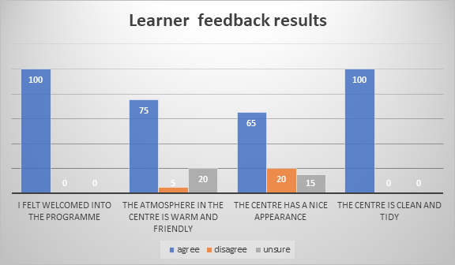

Q5. The teachers treat me with respect.
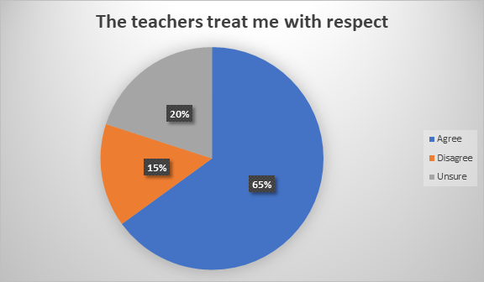

6. The subjects are interesting.
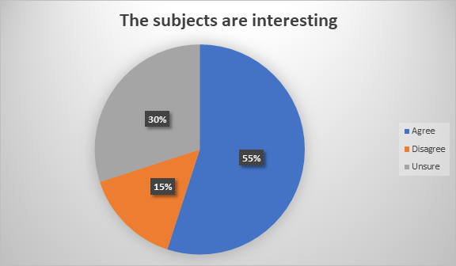
Q7 - 10
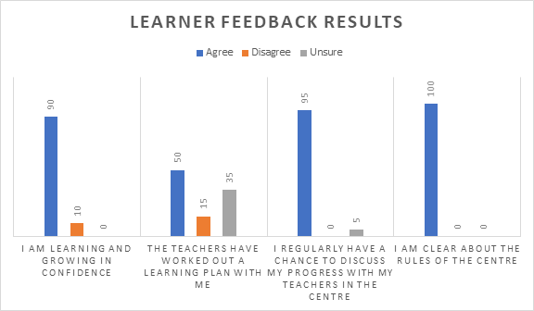

Q 11. I think the teachers make sure the rules are kept.
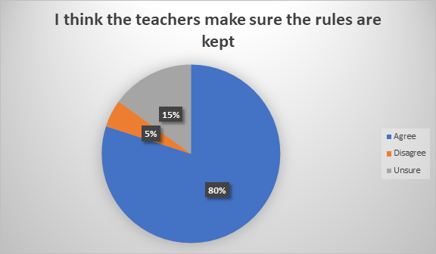

Q 12. I get a lot of encouragement from the teachers.
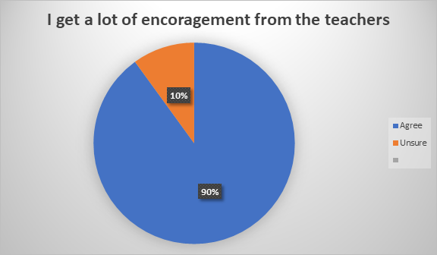

Q 13. My parents are happy that I am in this programme.
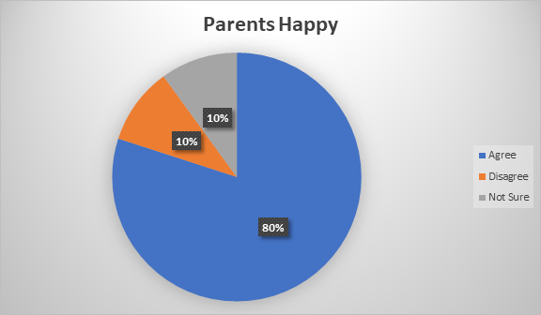

Q 14. I think that I will go on to another education / training programme / employment after I finish.
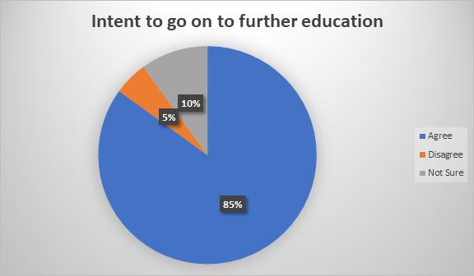

Q 15. I get on well with the other learners.

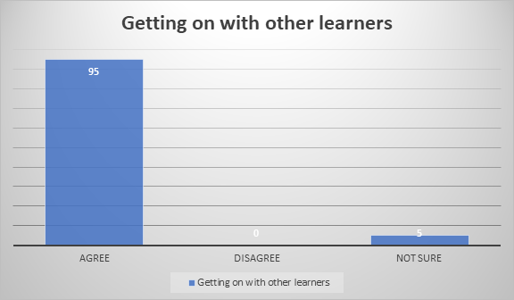

Q 16. The centre is well organized.

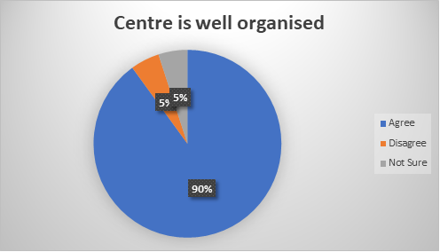

Q 17. Classes start on time.
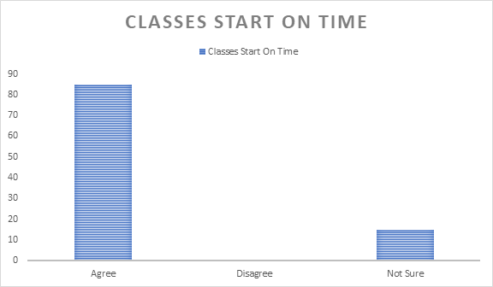
Q 18. I am proud to be in the centre.
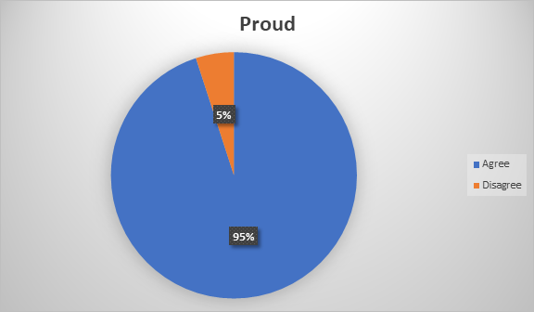

Q 19. I am happy with the qualifications on offer in the centre.

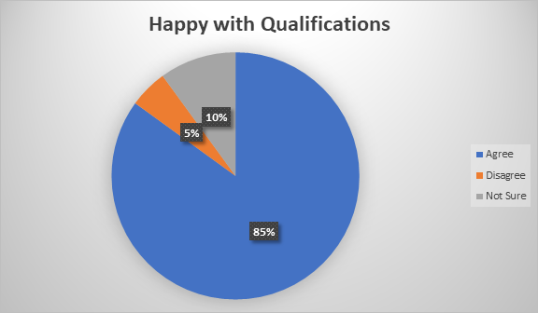

Q. 20 - 23
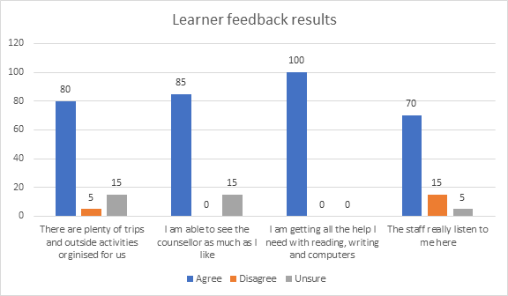

Q 24. The centre is well known in the community.
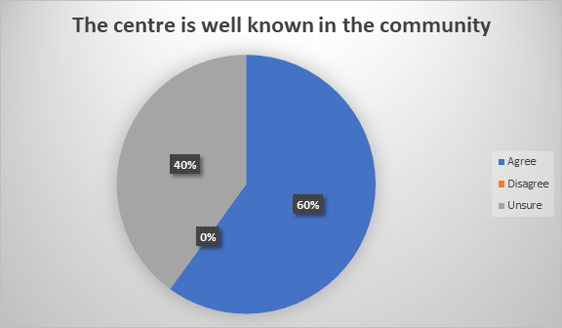

25. I get lots of notice if there are days off or trips planned.
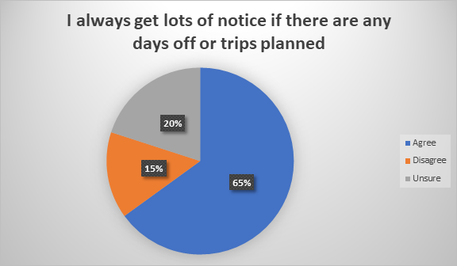

26. I have classes in SPHE every week.
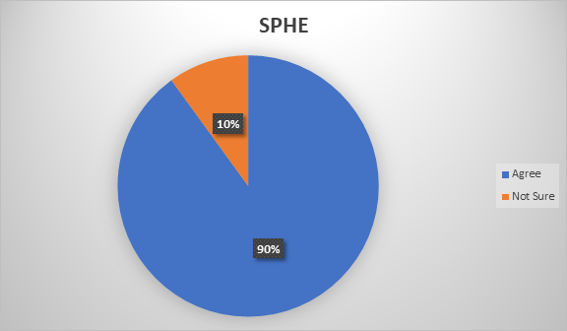

27. I am happy with the food provided by the centre.
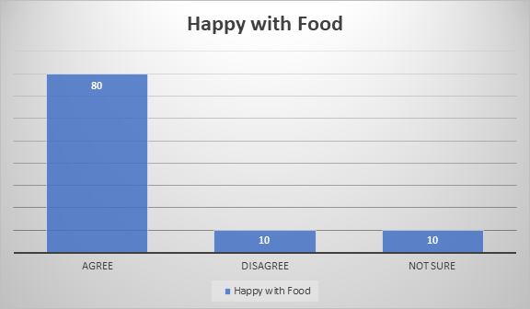

Emailed from a Number of Learners.

- Sinead making you a cake is nothing compared to what Youv done for me in my years in Youthreach, I wanted you to no Iv always been so grateful of all work and heartache Youv put into me and my school work, you gave me the encouragement and the drive that I really needed and never thought I had towards school, there’s so many of us that would be lost without you in there and especially my friend group, you truly are an amazing teacher and have honestly made such an impact on my life, hopefully when I finish we could still keep in contact because you are very important to me and I wouldn’t like to loose you as a friend never mind my teacher 💕

I just wanted to let you no how much I appreciate your support and Ultans you guys make Youthreach a safe place for so many of us and we were having a chat about how much you do for us all abs how we’d all live such different lives if we didn’t have you and the centre.

There’s not a day Iv done at work that gave me near to the feeling I get after a day in the centre, ye might not think it with all the abuse and stress we give but the centre has honestly been a place of salvage to me and the gang and we couldn’t ask for better leaders on our journey, I hope now that we can all do something before we split to remember each-other and everything we’ve share xx

- How’s things just wanted to tell you and would you tell Ultan and all I would have came today but I had important meeting today have car and getting insurance on it theory test book for next week happy 30th birthday 🙂 birthday 🎂 Ye were the best thing that ever happened to me. I always remember you ringing me at midnight when I text to say I was in a bad place. Won’t forget ya.

- I miss ye 2 I would do anything to go back there , best days of my life , the craic was always mighty! The boys are doing well❤️ Just got both of them into Creche and school in September so I’m just getting back to myself but hopefully after the new year I will get down for some tea in the new year..❤️

- Thank you so much for everything you’ve done for us over the past year and a half. It hasn’t gone unnoticed and we all really appreciate it 💜

- Thank you so much Sinead for everything over the past two years the support you and all the staff gave me I will never forget and will be forever grateful x I’ll call back to see ye soon today just wasn’t the best day to be there xx

- I’ve meant to send this message for days but really hoped I’d have got in to see you personally before you went on holidays. While I write this, I’m very emotional as I’m going to miss you so much and I know it’s the end of a chapter, things haven’t been easy for me over the past few months but without your guidance, support and sheer determination I wouldn’t have survived (I promise you that, you’ve made that difference). You got me through family bereavements and very low days. I also felt I could message you day or night without been judged. I know I’ll never ever be able to say thanks to the extent I would like to and you’ll never know what you meant to me. Sometimes I wonder how you took me through tasks and never gave up but that’s what makes Youthreach the place it is!!! Your our star 🌟 and please never loose contact!!! Sending you lots of hugs and have a fab summer with the family! X

Evaluation by centre Counsellor

Centre name: Youthreach Sligo
Name of respondent: Phill Corcoran
Professional qualifications: Degree Counselling/Psychotherapy. MIAHIP
Role within the centre: Counsellor and Mentor support and Supervision
Please answer the questions below along with any observations or comments that you would like to make.
- Are you aware of the main features of the SEN Initiative, i.e. what is expected to be happening in this centre as a result of the centre being a SENI centre (e.g. the use of Webwheel mentoring, the development of Individual Action Plans, the interagency liaison, the focus on staff training and on staff support and supervision)?

I am aware of the main feature of the SEN Initiative in our centre. The implementation of the Web Wheel is very relevant to our learners. It is used as a tool at mentoring; with its sixteen sections it gives the learner the opportunity to reflect on themselves under each section this encourages them to identify goals for themselves. It also helps the learners with their personal and social development, it relates to their lives outside of the centre.
- In your view, how well are the needs of the learners in the centre being met?

I feel the learner’s needs are met in every way possible. Ultan my coordinator suggests on the arrival of a learner to the centre that during the first few days of induction he/she would meet with me. I explain my role in the centre and assure them of as much support as possible while offering them of a safe space to discuss any issue that might be causing them a concern. I discuss (1) confidentiality (2) explain the issues around child protection in order that they are familiar with them (3) self-harm and harm to others is also discussed. By the time they are familiar with the Web Wheel, their key worker and have a match for the Web Wheel mentoring in place most if not all of their needs hopefully should be met in my view. Should it be needed I would refer to outside agencies such as Addiction Agency, Mental Health Organisation and GP or HSE.
During lockdowns the learners were supported by myself on the phone on a daily basis, and through teams where appropriate. I contacted all learners as required and offered my support where necessary. Many learners were vulnerable when access to the centre was removed and needed many supports which I followed up on.

- What do you see as being the main outcomes of the SEN Initiative in the centre?
The implementation of the Web Wheel helps the learner improve their development of life skills also basic skills and motivate them towards their future. From the Web Wheel they can recognise problems in their personal life that they may wish to address by degrees. By the learner’s ability to view the Web Wheel fortnightly they can explore his/her progress and develop many aspects of their lives.
- Are the staff sufficiently well supported to implement the SEN Initiative in your view? Have you any concerns about their capacity to do it or about the demands that are being put on them?

In my view the staff are well supported to implement the SEN Initiative. Supervision is provided every Tuesday at the start of the weekly staff meeting. Any relevant, reliable information or issue that might be pressing in relation to the learners or the staff is attended to at this stage. This would also include behaviours of learners that may need exploring and some attention given. Face-to-face counselling is available on request. Mentoring supervision takes place once per month. There is a debriefing slot daily. Staff training is in place from time to time.

5. What do you think of the overall impact of the SEN Initiative? Are there changes you would like to see introduced?
The overall impact of the SEN Initiative has been positive and a huge benefit to our centre. For now I cannot recognise any changes that could be needed.

- Have you any other observations or suggestions?

As a result of the SEN Initiative in the centre our learners have much more valuable benefit’s available to them. Without it there would be a noticeable difference in my view.

Teacher Subject Reviews;

LCA ICT Year 1, Year 2, General Learning - NALA & Computers, and Contemporary Issues Task

Ann Gallagher

September 2020 – July 2021

Summary of Subject Evaluations

I will continue to use the Moodle platform with LCA1 and LCA2 learners as I have course materials, formative assessments, resources, and screencasts prepared. I intend to introduce the LMS on a gradual basis, to expand learners’ knowledge of these types of learning systems. Learners will encounter such platforms in their further education and college choices, up to 85% of further and higher education courses used Moodle or Blackboard.

I will continue to use Moodle glossary with LCA1 and LCA2 as an introduction to collaborative learning and to encourage an active learning environment. Metimeter was a valuable interactive software that was employed online and in class during the year as it allowed real time interaction and anonymous feedback. My intention is to use it again.

My intention going forwards is to encourage more team/pair-based projects with LCA2’s, introduce coding through Scratch animation and STEM projects in addition to covering the LCA syllabus to give learners more 21st century skills. As I had set up most of my resources on Moodle before we returned in September 2020, I did not have a need to use MS Teams apart from using it for online classes. This year I am using a combination of Teams, Class Notebook, OneDrive Shared files, and Moodle throughout the year to get learners used to using different technologies and to increase their digital literacy. I also intend to give learners options for completing exercises using audio, dictate or recordings as well as typing as a UDL (Universal Design for Learning) approach to teaching and learning. I intend to give learners more feedback when completing projects and get learners to self and peer reflect on their projects. If we need to go online, make learners take part more in online classes using collaboration space in Teams and Google Jamboard.

Also, I will be developing many new resources for the revised LCA syllabus. This syllabus allows for a more progressive and dynamic teaching and learning environment.

Teacher Subject review 2019/2020
S.P.H.E.
Ultan Mulvihill.

I teach SPHE to all four groups in the centre. We currently have three Year 1 LCA groups and one year 2 LCA group.
I find that all four groups enjoy the subject and generally look forward to the class. We more often than not do not use laptops which the learners find refreshing as they are on their laptops a lot in other classes.
A lot of the time I use handouts / worksheets which prompt a group discussion. This works really well in two of the four groups. The other two groups seem to get more from doing the worksheets rather than the discussion which follows.
I also on occasion show some video clips of a topic but I find that this needs to be short as the learners tend to lose interest after a few minutes.

I have divided the course into sections based on the curriculum for schools from The Department of Education & Science. I sometimes veer away a little from this depending on what is topical in the centre at any given time.
Some of the feedback which the learners have given back to me includes
- It’s not like class, we’re having the crack.
- They were funny and entertaining.
- Cause I only now got to learn about myself positively.
- Because it gave us time to talk.
- It gets a good debate going.
- Fun to chat and discuss.
- I can state my opinion without being judged.
- Sometimes things people said were hurtful.

I would not change a lot for the coming year as I am happy with how most classes go.
I will however take part in training for RSE this year as I would have brought outside agencies in to give that part of the curriculum in previous years but was unable to do that this year due to Covid restrictions. Covid restrictions have restricted our group size to 6 or less and prevented us from bringing in outside agencies, on a number of topics. The masks are also a barrier as I can no longer see facial expressions when dealing with sensitive issues.

Subject: English
Tutors: Sinead McLoughlin and Judith Keyes
Groups: Leaving Certificate Applied Year 1 and 2

The key assignments for the Leaving Certificate Applied Programme are very clear cut and gives us scope in our programme design. We were aware of the number of weeks and teaching time between each term. We adapted work sheets to suit the individual needs, but some difficulties were experienced. The level of relevance was commented on negatively by majority of the group. A daily record was used to record all work and planning. There are some overlaps in certain subjects such as IT. We used several resources such as videos on the interactive whiteboard, quizzes, crosswords, audio book, DVD’s and library. Worksheets and handouts were adapted and updated when needed. Group interaction and peer learning were the most successful methodologies. Literacy and Numeracy was integrated through the design of appropriate worksheets. Key assignments, exam papers and project work were used to access learners work. Feedback is given to students on a daily basics. It is very important that students give feedback, the learners were given an evaluation form and students volunteer feedback in the classroom every day.
We are currently engaged in designing a more student-centred programme which will allow us access material which is more specific to the learner’s interests as the feedback given from the students was that the material was not relevant to their interests. We have invited a variety of guest speakers to the centre, for example Colm Keegan from Poetry Ireland, Eddie Leninhan, and Barry O’Flynn from the local credit union. Throughout the Covid pandemic we had to change our approach, so we had online lessons and we interacted with guest speakers online and did virtual tour of museums such as the Titanic Museum and the learners really enjoyed this activity. We had competition for writing activities and some learners engaged very well.

Sinead McLoughlin | Youthreach Resource Person

Evaluation summary – Marie Magill
General Education -
As there were no practical classes until December the General Learning group struggled with one-and-a-half-hour theory classes. Poor literacy skills, poor concentration and lack of interest made it difficult to hold their attention for 90 minutes. Online teaching with this group was difficult due to lack of attendance and lack of engagement when they did attend. I used videos, pictures, cutting and pasting, puzzles, artwork etc, to help motivate the students. We ‘struggled through until we could have practical classes and demonstrations. This is when the students had a renewed interest and enjoyed the ‘learning by doing’ approach to the subject.

LCA1 –
This class’s work was excellent with both online learning and the 90-minute theory classes. Progress was good and they have a good basis for going ahead with their second year of LCA in this subject. Again, they enjoyed the practical classes when they were resumed.

LCA2 -
This was difficult this year due to lockdowns and online teaching. Any students that attended on a regular basis managed to get on top of their tasks and complete them within the time allowed. However, the poor attendees dragged the process out for six months, showed no commitment or interest in the task and had nothing to submit at the end of this period. I could see those who were struggling or falling behind, and I tried my best to give them extra help to help them catch up. I changed tasks to simpler options for two students to try and help them. However, it is difficult to get work completed when students are continuously absent.

Teacher Annual Subject Review Eileen Ryan

Planning : There is always difficulty planning as we don’t have the timetable ready until the students return.
COVID measures and restrictions have greatly affect the planning as we did not know when and if things will change. It has restricted the opportunities we can have for the students as well as creating new ones.

No knowing in advance when trips etc will happen can also affect planning and you need to be very versatile and capable of adapting at short notice.

Student attendance and timekeeping are key factors in the delivering of a programme. Students arriving late at the start of the day or to class and likewise leaving early at the end of the day make it impossible to predict when ordering ingredients or preparing worksheets.

Practical cookery greatly affected by Covid as they were suspended for the start of the year and then could take place with only 4 student cooking at one time and the others to be facilitates with written work. The restriction applies to sharing of equipment and resources as well as having to take the cooked food home and being precluded from sharing.

For theory classes group discussion and use of prompts e.g. Powerpoints or video were successful but were affected if the students didn’t come to class on time.
Project work is effective but most students need a lot of support and are not great on self-directed learning. Team work is also affected by attendance and students leaving classes or being late

Team work and group discussion were effective as were the use of worksheets and puzzles or wordsearches.
Evaluations take place informally and throughout the year and can be valuable this way. We do not have a good “culture” of evaluation in the centre for formal evaluations so they can be less effective.

Teacher Subject Review Eamon Kelly

The teaching year was heavily impacted by Covid with a large part of the second term involving online teaching. This proved challenging in terms of technology and content. Youthreach teaching was also affected with activities such as group work virtually impossible. This led to a quite restrictive style of teaching which worked reasonably well with most groups but which the general learning group struggled with. I switched to making more use of a visualiser and white board for a period but returned to more traditional methods when the novelty wore off. In the gym it was interesting to note the enthusiasm for activities such as hurling badminton and tennis.

CEIP, SENI REFLECTION NOVEMBER 2021
KARL BURTHOM

Are the lessons being delivered effectively?
Yes but room for improvement because most of the time they are delivered only through one medium, Teams.
Teams is a very effective way of managing class material. I like using Teams because the lesson material is posted and returned in an orderly way. It’s easy to keep track of each class’s engagement. Assignments and the learners’ answers can be made colourful very easily and edited easily if they need amending (e.g. extending a deadline for handing in work or adding content to an assignment). Learners are alerted to any edits.
Using other methods of delivering class content have since been explored in an effort to improve engagement.
Are the learners engaging with the assignments and practical classes?
Some classes are engaging very well, others less so.
A problem is that some classes are only seen by me once a week. If any learners from such classes are absent then I might only see those learners very infrequently.
Some learners are unfamiliar with Teams. I am working with them to help them and improvements have been seen in terms of more assignments handed in.
Pen and paper are preferred by some learners and I have facilitated any requests to work in this way.
Thoughts on improving engagement.
Implement a mix of laptop work, practical music making activities and pen and paper. Keep handwritten work in plastic pockets for sanitary reasons in binders.
Deliver material in a variety of styles…quizzes, team activities, group work, presentations, games, power point presentations.
I need to take time to learn how to deliver some of these effectively. (For example, I haven’t prepared a power point presentation before).
I have encouraged learners to take their time and make their answers to assignments as colourful and interesting as possible. This might include including links to interviews, performances, artwork and so on. The hope is that the learners will enjoy the assignments more, plus those that enjoy challenging themselves can be as expansive as they want in their answers. It seems to be a common feature of assignment handed in that the work is rushed, one word answers and so on. I am encouraging the use of full sentences and research on the internet.
Any suggestions for improvements from learners?
Some learners have suggested two half hour classes instead of a single hour long class.
Some learners suggested using mix of laptop work, and pen and paper.

Any thoughts on improvements from me?
I feel I need to diversify the methods of delivery of my lessons ie have quizzes, team work activities, power point presentations and so on to improve engagement with assignments.
Have an array of methods of assessment. For example collect work handwritten on paper (quizzes, puzzles etc). I could use video to record learners playing an instrument. I could also use audio recordings of performances. At the moment all I have really are the assignments on Teams which I admit is useful but assessment could be improved by implementing methods described above.
I will follow up on suggestions from learners.
I will look up resources/ideas on the PDST website.
Positives so far?
Some classes are engaging very well and say they are enjoying the way the work is presented.
This year I have allowed for more time for practical music making.
The acquisition of an extra keyboard and four ukuleles have really helped the hands on music making sessions.
Problems so far?
Some learners have experienced a difficulty in submitting work through Teams due to being unfamiliar with it.
Attendance.
Motivating learners to submit completed assignments.
Solutions…
Watched Youtube tutorials for using Teams in class (if it was something I wasn’t able to fix).
Went through assignments in class highlighting how to answer questions. Sometimes I have had the group answer a question collectively to address this.
Some means of recording live music would be beneficial.

Teacher Annual Subject Review 2021 – Woodwork Damian Beirne
I found the module descriptor still acted as a guide, but, with covid restrictions, I relied more on relevant videos around the topics being discussed. For key assignments, I was able to send out resources & instructions on what to do. Upon completion, work could be sent back in self addressed envelopes. Some, but not all did the work. I tried to get the learners to incorporate maths, technical graphics & hand sketches of projects to be done. A lot of our project work concentrates on upcycling used materials, like pallets, etc,. This has been a gift recently, due to the ever increasing costs of building materials. I prepared a lot more work sheets for the learners, so they could replicate the finished drawings – to scale. I have included more frequent tool talks. Past papers are also a good pointer. Guest speakers were limited during covid 19 restrictions, though, the whole centre tended to benefit from speakers brought in previously! Learners have folders/projects ongoing. They know where they are at any given time. They are also caught up with at review. The learners completed a “student subject evaluation”, which can inform me of how they really feel about a particular methodology/topic.

Contemporary Issues Task
This is an active learning task that must be completed between September and the end of January. Learners used Menti, Padlet and Wakelet to set up their actions which were information classes as we could not organise trips or events due to COVID-19. These were very successful and promoted in-class discussions around their chosen topics. Learners used Microsoft Forms for their surveys. I provided feedback verbally and comments in task reports to assist learners completing their task reports. I also set up a Team for the contemporary issues task during lockdown and posted screencast videos, checklists of areas to be completed and shared resources that I had found to help learners complete the tasks.

Learners said they enjoyed using Menti and Wakelet for their actions in class and found the written feedback in their task reports very helpful during lockdown when completing the final sections. Some learners also used the resources I set up in the Contemporary Issues Team and said they found that useful.

Learner Subject Reviews;

LCA ICT Year 1, Year 2, General Learning - NALA & Computers, and Contemporary Issues Task

Ann Gallagher

Summary of Learner Evaluations

September 2020 – July 2021

LCA1
LCA 1 evaluation – learners indicated they were timetabled very little for the ICT and other activities were organised on the one day a week I had them, this was accurate and unfortunate so contact time was very limited. Many of these learners did not collect their laptops during lockdown and found it difficult to complete exercises on their smartphones. Some had completed ECDL in TY before joining Youthreach and indicated they would like more advanced word processing exercises. This is a fair point and a consideration for the future but was not possible due to lack of timetabled contact hours last year. I will be creating new resources for the new LCA and providing for differentiation and use design briefs that allow learners to be more creative. Some learners said they enjoyed the group work situations and asked for more group work which I am facilitating this year.

LCA2
LCA2 - Learners said they would like to do more creative projects with Photoshop using layers after the basics are covered. I have already incorporated more creative projects this year. One learner suggested learning text-based programming. This is not suitable for Leaving Cert Applied level but I am introducing Scratch block-based programming to the current LCA2’s as this is recommended in for the revised 2021 LCA syllabus. This will allow me to introduce STEM projects. One learner suggested starting with basics for everyone as many learners know how to use smartphones and touch screens but are not used to using a desktop computer or laptop. This is also a fair point, many learners know how to use smartphones but are not as ofay with using a computer or laptop which doesn’t have a touch screen.

General Learning Group
This General Learning group focused on basic computer literacy, using Microsoft Word, sending emails, using PowerPoint, creating avatars and Microsoft Teams basics. Discussion based learning and digital mind maps in PowerPoint were used in class from an accessibility point of view as many have low literacy levels.
Most of this group did not attend online classes which is unfortunate as I covered many digital wellbeing and many Microsoft accessibility tools and uses during these classes. Some of the group earned digital badges through NALA’s online level 1 and level 2 courses when they returned from lockdown in April.

The group fed back that they liked discussions on technology and ethics. They also enjoyed creating PowerPoint posters. This group did not suggest any changes for the future. This group is not running currently.

The following is a summary of the Student subject evaluations. ( Eileen Ryan )
Learners struggled with the mix of learning last year and the uncertainty of what was happening. They found the online learning tricky at the start but once they got the necessary help it was ok. They did appreciate the connectedness and the sense of routine that it brought.

They prefer interactive learning where they are involved in discussion and planning. They find a team task difficult as some of the team may not be in and therefore someone else has to carry the work.
Students found practical difficult due to restrictions and the variety of dishes they could produce.
Some students like solo work where they can be given a task to work away on with help from teacher if needed.
The timetable can be unbalanced e.g. theory subjects back to back, lots of one subject .
Some students said they dislike if the group is small or if they are on their own they don’t like the attention of the teacher on them , they also do appreciate it is a good opportunity to catch up on work if they need to.
Some of the content they felt was not relevant and some outdated ( Voc Prep) doing a cover letter when most applications are online.

Student subject review ( Marie Magill )
Students said they liked the interaction with staff in theory classes and were thankful for the help they got when they were in difficulty. The majority prefer practical classes to theory classes in catering. They find the power point presentations easy to understand and helpful when they are writing up tasks and key assignments. Many found online learning difficult as there were too many distractions at home, and it was difficult to concentrate.

Learner subject evaluation
SPHE
Ultan Mulvihill

I got 18 learner evaluation completed, and there were only 3 comments in the section on what parts did you lease enjoy.
They were;
- Sometimes I don’t like answering some questions out loud.
- Sometimes things people said were hurtful. ( not often )
- Listening to a person talk about his opinion for 5 – 10 minutes straight.

In the section on what part did you enjoy. These are some of the comments;

- Being able to discuss opinions with classmates
- I enjoy chatting and discussing. / I enjoy the group discussion
- Having a laugh
- The questionnaires / worksheets
- Learning / talking about myself
- All / every bit of it
- Experiences the students had
- The whole thing because Ultan is sound.
- Watching video on Mountjoy.

I use worksheets a lot to prompt a discussion and this works to varying degrees for all four groups.
From the evaluation sheets the majority of students seem to like having time to take part in discussions on various topics. The topics are chosen from the SPHE curriculum and sometimes we dip into other areas that are relevant at the time for the groups.
I will take on board that some students may have difficulty speaking out loud in the group, and maybe letting some students continue to give their opinion for 5 minutes or longer is too much and I need to manage that. I also need to check with students at the end of class that they are coping and not feeling hurt leaving the class after a discussion.
I plan to continue with the technique of prompting group discussion.

Hi Ultan,
Please find attached my reflection after the CEIP meetings.

I can give you a summary of the Learners' reflections here although these are also mentioned in the attached document.

Basically there was a mixture of Learners finding the classes very good and others finding them not interesting.
Some mentioned that they would prefer two half hour classes per week instead of a single hour long class.
Some expressed a preference for using pen and paper instead of a laptop.
All said that they were happy to be in Youthreach and that Youthreach was a great improvement on their experiences in their previous schools.
That about sums it up Ultan.
Kind regards
Karl

Teaching and Learning
What worked well in your timetabled subjects this academic year?
- Online session worked well using video, visual lessons
- Useful videos- made the control of the video.- u tube.
- Using work sheet to prompt discussion
- Through lockdown – online poetry – 6week programme
- Online virtual tours – key assignment
- Year book- individual- key assignment record
- Creative writing course –
- Variety of methodologies
- Power points
- Make contact with learners, over lockdown by phone, or text-
- Meet the learners virtual every day.
- On going counselling support-
- Discussions online- c
- Creative projects
- Coding –
- Working in groups encouraging team support.- coding
- Leisure and Recreation- introductions of new activities-
- Co operative games
- Using traditional methodologies.
What will you change going forward?
- Increased the visual content of the lesson
- I would use video more often- they use the drawing better.
- Planning week to week.-
- Introduce project week.-
- More feedback to students
- Take the lead from the learner.
How did COVID impact on Teaching and Learning this year?
- Unease around COVID positive in the centre.
- Exaggeration around the COVID situation
- Reduced numbers did help- they got through project.
How did COVID impact on Teaching and Learning this year?
- Unease around COVID positive in the centre.
- Exaggeration around the COVID situation
- Reduced numbers did help- they got through project.

Update and review of agreed actions created during the Sligo Youthreach CEIP evaluation 2020
Area | Action – on going |  | Person Responsible | tick when complete | Update 2021
Q.S. 23.(1) Teaching and Learning | - All staff are to ensure they are COVID aware and Risk Assessment compliant in their classrooms and workshop areas  - COVID 19 Documents are on the centre Share Point. ‘In Staff documents’ COVID 19 Risk Assessment  - Wood work – Partition  - Cooking / Kitchen  - COVID Risk Assessment on the agenda of the weekly staff meeting. |  | All centre staff- Ultan  Damien. Marie Eileen
Q.S. 18 .(4) Child Protection | Get the name of the duty social worker |  | DDL & DDLP |  | Update: Child Protection details/ Policy are displayed at the front entrance of the building.
Q.S. 18.(4) Child Protection | Inform the HSE or TUSLA, Duty Social Worker if a learner under review moves from the centre. |  | DLP DDLP |  | Update: Information via Care Plan meeting- with TUSLA – as needed/ required.
December 2020
Area | Action | Person Responsible |  | tick when complete | Update 2021
Q.S 23.3 (d) Teaching and Learning | All staff to put up their CPD in staff notebook on MS Team | All staff & Ultan |  |  | Update: All staff to put up their CPD in staff notebook on MS Team
Q.S. 18.1 Child Protection | Email MSLETB AEO Cormac Hanlan informing him that the centre’s Child Safeguarding Statement and Risk Assessment is out of date.  Request that the centre’s Advisory Group to ratify the Sligo Youthreach Child Protection Safeguarding Statement and Risk Assessment.. | Ultan |  |  | Completed and updated.  Displayed at the entrance of the building
Q.S. 18.1 Child Protection | - Include Child Protection on the agenda and minutes of staff meeting  - Minutes of staff meetings are on MS Teams SharePoint | Ultan |  |  | Update: Minutes- on the share point.
Q.S. 18.1 Child Protection | Email all staff requesting:  - Confirmation of their individual Child Protection Training  - Confirmation by return email | Ultan
Q.S. 18.2. Child Protection | - Re organise the Child Protection folder and filling cabinet.  - Create a specific Child Protection file. Folder, safe place for storing documents. | Ultan & Eileen
Q.S. 18.3. Child Protection | Decide on secure location for code deciphers documents. | Eileen, Phill & Ultan |  |  | Update: Securely lock in the Coordinator’s Office.
Q.S. 23.(4) Teaching and Learning | Seek clarification on when not to inform TUSLA of Child Protection issues | Eileen
January 2021
Area | Action |  | Person Responsible | tick when complete | Update 2021
Q.S. 23 Teaching and Learning. | Create time to work with Learners to upgrade their ITC skills- on the agenda of the Jan Planning meeting |  | Ann, Ultan
Q.S. 23.(1) Teaching and Learning: Assessments | Initial Assessments of learners- Marie to come to Ultan with ‘Assessment suggestions’ |  | Marie |  | Update: Training in WRAT 5 Assessment taking place in Jan 2022
Q.S. 6 .Record Keeping | Bring the Leaving Certificate Result reference GDPR to the Jan Monthly Review Meeting for discussion. |  | Ultan |  | Up date: LCA results GDPR clarification: Jan Review meeting.
Q.S. 23.(1) Teaching and Learning | Include ‘Respect in the class and the centre’.on the agenda of Jan 12th staff meeting |  | Ultan |  | Up date: ‘Respect in the class and the centre’. on the agenda of Jan 12th staff meeting
Mission Statement | To update the centre Mission Statement. |  | Mgt Team
Mission Statement | Display to centre Mission Statement in the centre. |  | Mgt Team
Staff Training | Develop a Training Document on Course available to staff – share this document on the centre’s SharePoint.- include on the agenda of the Jan 2021 Planning day meeting |  | Ann and Sinead
February 2021
Area | Action |  | Person Responsible | tick when complete | Update 2021
Q.S. 18.8. Child Protection | - Check Aid West- online Courses |  | Ultan |  | Reaction
March 2021
Area | Action |  | Person Responsible | tick when complete | Update 2021
Q.S. 18.7. Child Protection | - Update and revised the CIP  - Put up the revised CIP on SharePoint |  | Sinead, Ultan and Mgt Team |  | Update: On share point -updated
April 2021
Area | Action |  | Person Responsible | tick when complete | Update 2021
Q.S. 18.7. Child Protection | Develop an Intimidation Policy as part of the centre’s Anti Bullying Policy and Procedures |  | Whole staff team |  | Reaction: Include an Intimidation in the centre’s Anti Bullying Policy. Jan 2022 18.7
May 2021
Area | Action |  | Person Responsible | tick when complete | Update 2021
Preparation documents for CEIP 202 | Teacher Subject Reviews |  | All staff |  | Teacher to update for 2022
Preparation Reviews for CEIP 2021 | Learner Subject Reviews |  | All staff with learners |  | Teachers and Learners- update for 2022
Preparation Reviews for CEIP 2021 | Update |  | Staff with learners |  | Update May 2022-Ultan
Preparation Reviews for CEIP 2021 | Parent/ Guardian Review/ Sen and CEIP |  | Sinead |  | Parent/ Guardian Review/ Sen and CEIP Sinead- 2022
Preparation Reviews for CEIP 2021 | Profile of Learners |  | Sinead & Ultan |  | Resend Profile of Learners to Ultan
Preparation Reviews for CEIP 2021 | MSLETB Management Review Cormac Hanlon - |  | Ultan |  | Cathy was attendance
Preparation Reviews for CEIP 2021 | History of the centre |  | Ultan and Sinead |  | Update history
Preparation Reviews for CEIP 2021 | Counsellor |  | Phill |  | Update Phill in attendance
August/ September 2021
Area | Action |  | Person Responsible | tick when complete | Update 2021
Q.S. 6 .Record Keeping | DATA Projection training- for all staff Create a GDPR guidelines for staff. |  | Eileen & Ann link Ultan |  | Update: DATA Projection training- for all staff Create a GDPR guidelines for staff. 2022
Q.S. 23.3 (C) Teaching and Learning | Include technology in programme plans. 2021 |  | Timetabled staff |  | Update: Include technology in programme plans. 2022

23 Teaching and Learning 2021  23.1 The centre is focused on making a positive, measurable and significant difference to the quality of teaching in the centre. |  | Evidence | Area for Improve ment | Action | By Whom | When
(a) | Staff-Learners, Learners-Learners and Learners-staff interactions are respectful. | - Code of Conduct  - Ethos  - Mission statement  - Observations of interaction  - Monthly reviews-self reviews-staff/Learners  - Centre review  - ‘Respect’ as part of the Centre induction programme. |  | Include on the agenda of staff meeting  ‘Respect in class & the centre’. | All staff | Ongoing
(b) | Expected learning intentions/outcomes are  - curriculum and syllabus based,  - differentiated to cater for individual learning needs  - set out in teachers programme plans | - Programme Plans.  - Module descriptors  - Action plans  - Results/  - Outcomes/ key assignments  - Learners/learner subject reviews/feedback  - Monthly reviews- action plan
(c) | Staff share and vary the content, activities, methodology and resources and take into account the range of interests, needs and experience of all Learners | - Staff meetings share information  - Formal and informal sharing information  - Staff Feedback from reviews  - Staff debrief session each day- pre COVID  - Share point- centre for staff.
(d) | Learners participation, contributions and questions are encouraged and their efforts and achievements are affirmed in the classroom. | - Observations  - Mind maps  - Verbal comments  - Class discussion  - Teacher diary, class notes, reflections  - Learner sub reviews  - Breakfast- Assemble meeting- pre COVID  - Photographic affirmation of learner’s work.- on display- pre COVID  - Moodle- quizzes/ feedback  - Virtual feedback  - Virtual staff meeting.
(e) | Team teaching, collaborative learning and extracurricular opportunities are evident in centre programmes, where appropriate. | - Team teaching Timetabled.  - Outside agencies. Pre COVID- now online  - LCA tasks  - SPHE /RSE  - Collaborative learning- Moodle Glossary of Terminology LCA 1 & 2.
(f) | Learners are provided with meaningful feedback on their work, during and at the end of the class, to improve their learning. | - Work sheet -Verbal discussion.  - Learner Folders-  - Work sheets  - Bookending your class.  - Feedback at end of class  - Evaluations sheets-eg topics  - Quiz to test knowledge.- Moodle.
(g) | Information regarding Learners progress is shared with relevant staff members as necessary | - Staff  meetings virtually  - Monthly Reviews  - Debriefs - Pre COVID  - Self review/Monthly review.  - Informal sharing of learner progress.
(h) | Attention is given within each subject/programme to the development of Learners’ Language, Literacy, Numeracy and new technologies. | - Catch the moment  - Labeling in class/work area- pre COVID  - Key words  - Literacy link board. Pre COVID  - Interactive white board  - Data projectors.  - Glossary on Moodle- ITC  - WRAT 4/5 |  | .
(i) | Classroom/learning areas are organised in a manner that supports learning, they are appropriately laid out, well-resourced and orderly | - Well resource centre.  - Bright warm rooms.  - Internet  - Safe place  - Risk assessments COVID- live document- regular review.  - Health and Safety Risk Assessment.  - Centre is COVID compliant. |  | - Staff ensure, that they are COVID Aware and Risk Assessment compliant in their classrooms and workshop areas, in compliance with updated Government guidelines.  - COVID 19 documents are on the centre Share Point. ‘In Staff documents’ COVID Risk Assessment.  - Wood work room, & other practical subject work areas are partitioned.  - COVID Risk Assessment on the agenda of the staff meetings. i | All centre staff- Ultan  Damien. Marie Eileen
(j) | A visually-stimulating, print-rich environment with high-quality displays of subject-related material and Learners’ work is evident in classrooms and corridors. | - Visual evidence.  - Stimulating environment  - Christmas display  - Display cabinets- COVID compliant
(k) | Learners are supported to engage actively in their learning. | - Mentoring  - Reviewing  - Feedback  - Action plans  - LCA Tasks/ projects |  | All staff to complete WRAT 4 & 5 assessment training. | All staff | Jan 2022
23.2 The centre is focused on making a positive, measurable and significant difference to the quality of learning in the centre. |  | Evidence | Area for Improve ment | Action | By Whom | When
(a) | Learners are supported to develop team skills, through a wide range of class and non- classroom based activities, cross curricular experiences, collaborative learning and extracurricular activities. | - Centre diary- daily event book.  - LCA Enterprise task  - Sport activities –Pre COVID  - SPHE/ RSE programme  - Girls active programme Pre COVID  - Table tennis- Pre COVID  - LCA tasks  - Green project-  - Time table- Pre COVID  - Sligo Higher Institute  of Technology  Learners-Sports and Recreation.- Pre COVID  - Social Learners Sligo I.T.C.- Pre COVID  - Home Economic Learners ST Angel’ s College Pre COVID  - Learner Garda - Pre COVID  - Marino Institute Learners- Work placement- Pre COVID  - Learner pods in line with Gov. regulations
(b) | Learners are adequately challenged engaged and supported in their learning, so that they make satisfactory progress. | - Monthly Reviews  - Actions plans  - Challenged in class  - Learner’s folders  - Match learners to most appropriate group for learning. -
(c) | Learners are encouraged to engage purposefully in the class in an enjoyable positive learning environment. | - Group work - Pre COVID  - Discussions  - Variety the class content  - Flexibility – over approach- own input-  - Match materials to learner needs, abilities & mood.  - Learners evaluation forms
(d) | Learners are provided with opportunities to reflect and give regular feedback on  - the class  - their learning  And achieve expected outcomes. | - Learner subject reviews  - Learner feedback during reviews  - In class- comments  - Results of class content.  - Teams assignment feedback.  - Examination results  - Moodle – feedback.-
(e) | Staff have the flexibility to adapt programme content, activities and methodologies in order to support Learners who may be at risk of under achieving | - Flexibility of adapting class content.  - Teacher diary content  - Experienced staff  - Feedback for learners.  - Learners class methodologies- change based on learner feedback.

23.3 The centre uses technology to facilitate and support innovative teaching and learning practices |  | Evidence | Area for Improve ment | Action | By Whom | When
(a) | The centre is equipped with appropriate broadband and Wi-Fi capacity. | - Working WiFi & Broadband the system.
(b) | Technology to enhance learning is available in the centre. | - ICT equipment  - Projector in each classroom.  - WiFi  - MS Teams  - Moodle.  - ICT MSLETB support available  - Remote learning timetable during COVID lockdown period
(c) | Technology is used appropriately as part of all teaching and learning | - Staff have different levels of technology ability.  - Learner subject evaluation.  - Each learner has their own laptop.  - Included in teacher’s programme plans. |  | Teachers to ensure technology of their subject are included in their programme plans. 2022. | Timetabled staff | Sept 2022
(d) | Through continuous professional development staff feel confidence in using up to date technology effectively to teach and to enhance learning | - COVID Technology CPD provide by MSLETB.  - Teacher’s can request individual ITC support  - CPD staff- hard copy of training completed. (certification/evidence) |  | All staff to put up their CPD on staff Notebook on MS Team | All staff Ultan | Dec 2021-22
(e) | The centre uses technology to enhance communities of learning and practice (COP) among staff and learners. | - Training in MS Teams  - Staff Note book records  - Share point-includes centre meeting, minutes, calendar, Policy and Procedure.  - MS Team record of COP  - During lock down –remote class  - Availability of Remote ‘Monthly Review’.  - Revised LCA ITC course.- COP.
(f) | Staff share models of good practice on technology enhanced learning regionally, nationally and internationally. | - MSLETB training in enhanced technology available for staff.  - MSLETB TEL site- information on training and courses available.  - MSLETB Resources-  - MSLETB Advisory Committee meetings occur remotely.
(g) | Learners are skilled and confident in using technology as part of their work, study and home life | - In class and at home.  - Phones –  - 62%Learner have devises at home  - Assessing learners ‘digital stepping stones’ survey. |  | Assessing learners ‘digital stepping stones’ survey. 2022 | Ann | Jan 2022
(h) | Learners are more engaged and achieving more from their learning through the use of TEL | - TEL is on the timetable  - Massive shift in learning and competence for learner and staff  - Moodle data  - Mirco soft forms- quiz and assessments  - Remote teaching | Consider use the ongoing use of computer/ lap tops. | Eamonn-to complete a survey of learners use of laptops | Eamonn | Jan 2022
(i) | Significant improvement can be made in access to further education, training and career progression as a result of TEL | - SUSI grant applications  - Career guidance – career planning – PLC, Courses research  - Career Portal |  | - Contact MSLETB regarding the replacement of a the career guidance service in the centre.  - Research short term career guidance person either in person or an on line source for LCA year 2 group | Utlan | ASAP

Q.S 5. Administration and Financial Management  5.1 Administration arrangements meet the needs of all stakeholder groups. |  | Evidence | Area for Improvement | Action | By Whom | When
(a) | Administration support is allocated as appropriate between the centre and the ETB Office. | - Administration support provided by LMSTB  - In centre administration support provided by Yvonne – Three days a week  - Staff payment now a on a new National system.-  - Learner hour, and account payment via MSL ETB
(b) | The administration staff carry out the key administration functions relating to the programme. | - Yvonne centre administration support carries out key administration functions relating to the programme.
(c) | Relevant equipment and resources are provided in order to carry out all administration functions. | - Relevant administration equipment & resources are in place-  - MSLETB has carried out a survey on the centre’s printers, and paper use count.
(d) | Clear procedures are in place in relation to all administration tasks in line with ETB and IAU - Internal Audit Unit - formally VSSU guidelines. | - Follwing MSLETB administration guidelines.  - Purchasing codes systems are in place  - Annual ramdom Aduit Checks  - PLSS checks re evidence.  - Administration new system- weekly tracking work load by FET-
5.2 Finances are managed in a manner that meets the needs of the centre and are in compliance with National guidelines |  | Evidence | Area for Improve ment | Action | By Whom | When
(a) | The Co-Ordinator is provided with an approved budget for the programme. | - Monthly budget report from MSLETB  - Term report & budget updates, presented to the MSLETB Advisory Committee – Pre COVID |  | Request a monthly budget update for both SENI & the centre from AEO Cathy Powell | Ultan | Dec 2021
(b) | Appropriate training is provided for management and key staff in relation to budgetary matters | - Training has been provided as required.  - Awaiting further instruction on ‘Procurement team training for Coordinator’
(c) | Pay and non-pay budgets are effectively planned and managed by the Co-Ordinator in conjunction with local management and the relevant personnel in the local ETB. | - Monthly report to AEO - pre COVID  - Advisory Committee Term report- pre COVID
 | Supplies and services are ordered in accordance with the approved purchasing procedures of the ETB. | - Order book.  - Invoice & copy with invoice sent to MSLETB.  - The centre copy & supplier copy- all coded.  - Supplies ordered signed by coordinator & ordering staff.  - Recorded in centre ‘Stock Book’- as necessary.
(e) | All necessary financial records are maintained and stored safely. | - Financial records maintained in centre & in MSLETB.  - All records are stored in a secure & safe place  - Data base of financial records are on file.
(f) | Financial management systems are subject to external audit. | - ETB audit  - IAU audit
5.3 Adequate insurance cover is in place to cover all activities of the programme. |  | Evidence | Area for Improve ment | Action | By Whom | When
 | Written confirmation of insurance cover is in place. | - Annual Insurance cover- coving all aspects of the programme.  - IPB will only cover insurance claims if the ETB are negligent.
 | Additional insurance cover for any new programme/activity is sought and received prior to engaging in new programmes/activities. | - Requested & sought if required/ necessary- ref Filming in the court house- pre COVID.

6. Record keeping  6.1 Records relating to key aspects of the programme are maintained in accordance with National Data Protection Guidelines. |  | Evidence | Area for Improvement | Action | By Whom | When
(a | A data protection policy - in line with the Office of the Data Protection Commissioner - is in place in the centre. | - Centre Data Protection Policy in line with MSLETB & the Office of the Data Protection Commissioner. |  | Research Data Protection Training for the centre staff | Ann | April 2022
(b | Staff are aware of and familiar with data protection obligations. | - Coordinator & staff have completed MSLETB Data Protection Training.  - Staff GDPR training took place- May 2019.

(c | Due care is taken to protect confidential information in line with data protection legislation. | - Confidential information securely stored in line with Data Protection legislation.  - All documents are filed in a secure in a locked filling cabinet.  - Secure Code system on office door  - Confidential documents are shredded.  - DDLP & DLP Child Protection documents are kept in a locked cabinet

(d) | Records in relation to staff are maintained to include recruitment details, relevant contracts, claim forms, annual leave, sick leave, staff development programmes that staff engaged in, programmes of work and evaluations as relevant | - Records in relation to staff recruitment detail, contracts  are maintained in MSLETB. H.Q.  - Records of staff claim forms, annual leave, sick leave, are recorded on line by the coordinator  - Staff development, programmes of work and evaluations are maintained in the centre & or in MSLETB HQ,  - Part time hours – on line claim form sent to ESBS.

Q.S. 19 Code of Behaviour  19.1  Learners are encouraged to behave in an appropriate manner. |  | Evidence | Area for Improvement | Action | By Whom | When
(a) | A positive Code of Behaviour is developed and implemented in a fair and consistent manner in compliance with departmental guidelines | - Code of conduct approved by Advisor Committee and the Youthreach centre staff  - Centre discipline ‘Step System’ in place.  - ‘Steps System’ is recorded on learner’s & Centre records.  - Under 18yrs olds a copy of ‘Step Records’ are sent to parent/guardian.  - Learners ‘Steps System’ , records are reviewed during the Centre’s Monthly Review sessions
(b) | The Code of Behaviour outlines learners’ rights, responsibilities and a grievance procedure. | - The Centre’s Code of Behaviour Policy and Procedures outlines learners’ rights, responsibilities and a grievance
(c) | The Code of Behaviour outlines procedures for dealing with the misuse of drugs. | - Substance misuse- is included in the centre’s Code of Behaviour.
(d) | The Code of Behaviour has the support of parents/guardians, staff and learners and local ETB. | - The Code of Behaviour has the approval of MSLETB  - The document is sign off by all learner.  - Parent/ guardian- of under 18yrs olds sign the document  - The centre Code of Behaviour is on the centre website, |  | - Include the centre’s ‘Code of Conduct’ parent/ guardian consent sign off document in the parent/ guardian induction pack for signage.  - Follow up with parent/ guardians who have not signed off on the centre’s Code of Conduct. | Ultan | Dec 2021
(e) | Clear records are maintained in relation to the implementation of the Code of Behaviour. | - Step System records- are written up by the teacher who have given the step to the learner.  - ‘Step’ Records  - Code of Behaviour issues are on the agenda of Advisory committee, if necessary/ required
(f) | An anti-bullying policy is developed, documented and implemented in a fair and consistent way in compliance with the Department of Education and Skills guidelines | - The centre anti bullying policy / Code of conduct documents has been approved and signs off by MSLETB Advisory Committee. And has been–  - The review date of the policy and procedures is recorded on the document. |  | Code of Behaviour / Anti bullying Policy review date November 2022. By the MSLETB Advisory Committee | Advisory Committee | November 2022.
(g) | Information and training in relation to anti-bullying, cyber bullying is provided for all staff. | - Centre staff have completed Anti bullying training in the past |  | Contact Gerry Griffin with regards to Anti bullying & Cyber bullying training for staff  Ulton to contact AEO Cathy Powel re above | Theresa  Ultan | ASAP
(h) | Staff, learners, parents/guardians are made aware of and fully support the implementation of the centre’s anti-bullying policy. |  |  | Contact parents/ guardians of under 18yrs- olds learners, informing them that the centre policies and procedures are on the centre’s Website. | Ultan & Yvonne | Jan 2022

29. Social, Personal and Health Education  29.1 In line with the Education Act (1998), centres promote the social and personal development of all learners and provide health education for them through a broad ranging and integrated programme of SPHE |  | Evidence |  | Area for Improvement | Action | By Whom | When
 | The centre has an SPHE/RSE Policy and corresponding Procedures in place in line with Department of Education requirements | - Policy and procedure in place
 | A programme of learning in the area of SPHE/RSE is developed and delivered to all learners | - SPHE & RSE is timetabled once a week for all groups.  - Attendance records
 | A programme of learning in the area of SPHE/RSE is timetabled appropriately as part of the overall curriculum of the centre. | - SPHE & RSE is on the centre timetabled for each group |  |  | Follow up on cancelled RSE training | Ultan | ASAP
 | Programmes plans in the area of SPHE/RSE that are developed and documented by staff address areas such as self-awareness and emotional health, self-management, belonging and integrating, communication skills, friendships, conflict resolution, relationships, sexuality and sexual health, influences and decision-making, substance use, personal safety and knowing when and how to seek help | - The recommended content of the SPHE/ RSE programme are included in the SPHE/ RSE programme plans  - RSE guess speakers- 2019  - The SPHE & RSE course is integrated with other timetabled subjects in the centre  Home Economics;  Leisure & Recreation;  Social & health Education.
 | As a result of the SPHE/RSE programme and related activities learners have a better understanding of key topics covered | - Learner folders content work.
 | As a result of the SPHE/RSE programme and related activities learners have access to internal and external pathways for support if needed | - As a result of discussion & sharing information during the SPHE/RSE classes learners have a clearer understanding of supports available  - Support within the centre  - SENI- mentoring programme  - Centre Councillor Phill-  - Councillor also available via Phone .
 | Soft skills development of learners are acknowledged, recorded and evaluated annually as part of the Quality Framework Process | - The SPHE programme is reviewed on going- what is working well or not.  - Learner’s comments are positive.  - Phill, the centre councillor, regular checks in with staff regarding learners.  - Learner ‘Monthly Reviews’- behaviour, work area, contributions, progress etc – setting target for the upcoming month.

Strengths, Skills and Spirit of our Team in Youthreach Sligo

‘

Calendar of Agreed Actions 2021 - 2022
To be included on the agenda of each staff meeting
Time Line of Actions Created from the CEIP Process Sligo Youthreach 2022
Ongoing actions during 2022
Area | Action – on going | Person Responsible | tick when complete
Q.S.23.3 (d) Teaching and Learning: recording staff CPD 2021-2022 | All staff to put up their CPD on staff Notebook on MS Team d | All staff Ultan
Q.S.23.1 (i) Teaching and Learning: COVID Awareness | - Staff ensures, that they are COVID Aware and Risk Assessment compliant in their classrooms and workshop areas, in compliance with updated Government guidelines.  - COVID 19 documents are on the centre Share Point. ‘In Staff documents’ COVID Risk Assessment.  - Wood work room, & other practical subject work areas are partitioned.  - COVID Risk Assessment on the agenda of the staff meetings. | All centre staff- Ultan  Damien. Marie Eileen
Q.S.23.1 (a) Teaching and Learning: Respect in class & the centre’ | Include on the agenda of staff meeting  ‘Respect in class & the centre’. | All staff
December 2022
Area | Action | Person Responsible | tick when complete
Q.S.19 Code of Behaviour (g) | Contact Gerry Griffin with regards to Anti bullying & Cyber bullying training for staff  Ulton to contact AEO Cathy Powel re above | Theresa  Ultan
Q.S.5 Administration & Finance 5.2 (a) Centre budget | Request a monthly budget update for both SENI & the centre from AEO Cathy Powell | Ultan
Q.S.23.3 (i) Teaching and Learning: Career Guidance councilor. | - Contact MSLETB regarding the replacement of a the career guidance service in the centre.  - Research short term career guidance person either in person or an on line source for LCA year 2 group | Utlan
Q.S, 19 Code of Behaviour (d) | - Include the centre’s ‘Code of Conduct’ parent/ guardian consent sign off document in the parent/ guardian induction pack for signage.  - Follow up with parent/ guardians who have not signed off on the centre’s Code of Conduct. | Ultan
Q.S. 19 Code of Behaviour (f) | Code of Behaviour / Anti bullying Policy review date November 2022. By the MSLETB Advisory Committee | Advisory Committee
Q.S.29 SPHE (c) SPHE & RSE is on the centre timetabled for each group | Follow up on cancelled RSE training | ASAP
January 2022
Area | Action | Person Responsible | tick when complete
Q.S. 23.(1) Teaching and Learning: Assessments | Update: Training will take place WRAT 5 Assessment Initial Assessments of learners- Marie to recommend an ‘Assessment suggestions’ to Ultan | Marie
Q.S. 6 .Record Keeping | Bring the Leaving Certificate Result reference GDPR to the Jan Monthly Review Meeting for discussion. | Ultan
Q.S. 23.(1) Teaching and Learning | Include ‘Respect in the class and the centre’. on the agenda of Jan 12th staff meeting | Ultan
Q.S. 18 .(4) Child Protection | Update from CEIP Report 2021: Get the name of the duty social worker  Update: Child Protection details/ Policy are displayed at the front entrance of the building. | DDL & DDLP
Q.S. 18.(4) Child Protection | Update from CEIP Report 2021: Inform the HSE or TUSLA, Duty Social Worker if a learner under review moves from the centre.  Update: Information via Care Plan meeting- with TUSLA – as needed/ required. | DLP DDLP
Q.S 23.3 (d) Teaching and Learning | All staff to put up their CPD in staff notebook on MS Team  Update: All staff to put up their CPD in staff notebook on MS Team | All staff & Ultan
Q.S. 18.1 Child Protection | Email MSLETB AEO Cormac Hanlan informing him that the centre’s Child Safeguarding Statement and Risk Assessment is out of date.  Request that the centre’s Advisory Group to ratify the Sligo Youthreach Child Protection Safeguarding Statement and Risk Assessment..  Completed and updated.  Displayed at the entrance of the building | Ultan
Q.S. 18.1 Child Protection Update: Shared on SharePoint | - Include Child Protection on the agenda and minutes of staff meeting  - Minutes of staff meetings are on MS Teams SharePoint | Ultan
Q.S 23.3 (d) Teaching and Learning | Reaction from CEIP Report 2020: All staff to put up their CPD in staff notebook on MS Team | All staff & Ultan
Child Protection 18.7: Develop an Intimidation Policy as part of the centre’s Anti Bullying Policy and Procedures | Reaction: from CEIP 2020 Report: Include an Intimidation in the centre’s Anti Bullying Policy. | Whole staff team
Q.S.23.3 (g) Teaching and Learning: Learner’s digital stepping stones’ survey. | Assessing learners ‘digital stepping stones’ survey. 2022 | Ann
Q.S.23.3 (h) Teaching and Learning: Learner laptop survey | Eamonn-to complete a survey of learners use of laptops | Eamonn
Q.S.23.1 (k) Teaching and Learning: Staff assessment training | All staff to complete WRAT 4 & 5 assessment training. | All staff
Q.S. 18.7 Child Protection: Intimidation Policy | CEIP Report 2020: Reaction: Include an Intimidation in the centre’s Anti Bullying Policy. | Centre Mgt Team
Q.S. 19 Code of Behaviour (h) | Contact parents/ guardians of under 18yrs- olds learners, informing them that the centre policies and procedures are on the centre’s Website. | Ultan & Yvonne
February 2022
Area | Action | Person Responsible | tick when complete
Mission Statement | To update the centre Mission Statement. | Eileen
Mission Statement | Display to centre Mission Statement in the centre. | Eileen
Q.S. 18.8. Child Protection | Reaction from CEIP Report 2021: Check Aid West- online Courses | Ultan
March 2022
Area | Action | Person Responsible | tick when complete
Q.S. 18.7. Child Protection | Reaction from CEIP 2020 Report:  - Update and revised the CIP  - Put up the revised CIP on SharePoint | Sinead, Ultan and Mgt Team
April 2022
Area | Action | Person Responsible | tick when complete
Q.S.6 Record Keeping: (a) Data Protection Training for staff | Research and organise ‘Data Protection’ Training for the centre staff | Ann
May/ June 2021
Area | Action | Person Responsible | tick when complete
Preparation documents for CEIP 2022 | Teacher Subject Reviews | All staff | May /June
Preparation Reviews for CEIP 2022 | Learner Subject Reviews | All staff with learners | May /June
Preparation Reviews for CEIP 2022 | Learner Centre Review | Ann | May /June
Preparation Reviews for CEIP 2022 | Parent/ Guardian Review | Sinead | May /June
Preparation Reviews for CEIP 2022 | Profile of Learners | Sinead & Ultan | May /June
Preparation Reviews for CEIP 2022 | MSLETB Management Review Cathy Powell | Cathy Powell | May /June
Preparation Reviews for CEIP 2022 | History of the centre | Ultan and Sinead | May /June
Preparation Reviews for CEIP 2022 | Advocate/ Career guidance | Ann Hefferon | May /June
Preparation Reviews for CEIP 2022 | Counsellor | Phill | May /June
June/ July2022
Area | Action | Person Responsible | tick when complete
Q.S. 18 .(4) Child Protection | Get the name of the duty social worker Update: Child Protection details/ Policy are displayed at the front entrance | DDL & DDLP
August/ September 2022
Area | Action | Person Responsible | tick when complete
Q.S. 6 .Record Keeping | DATA Projection training- for all staff Create a GDPR guidelines for staff. | Eileen & Ann link Ultan
Q.S. 23.3 (C) Teaching and Learning | Teachers to ensure technology of their subject is included in their programme plans. 2022. | Timetabled staff
October /November 2022
Area | Action | Person Responsible | tick when complete
Preparation documents for CEIP 2022 | Bring all CEIP reviews together | Ultan

